Iterables & Loops p.IV
Complex Algorithms
Exercises

Rock, Paper, Scissors 2
Ball Movement 3

Rock, Paper, Scissors
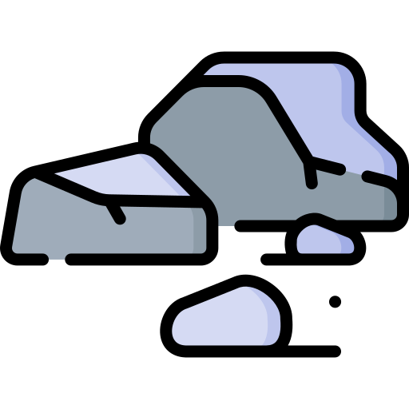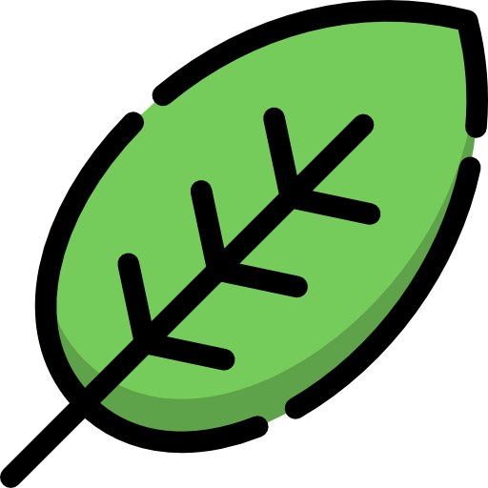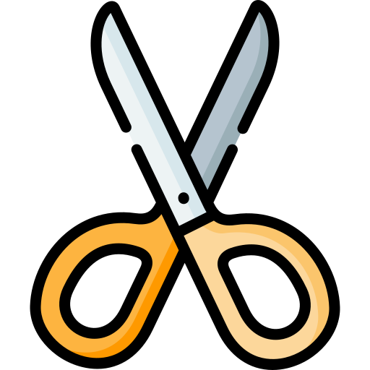
Create a simple one player Rock, Paper, Scissors game in Python. The game is a best-of-three match. The player is playing against the computer. After each match, display the scores and allow players the option to play again.
Remember the basic rules:
- Rock crushes Scissors.
- Scissors cut Paper.
- Paper covers Rock.
Instructions
- Initialize Variables
  - Track scores for each player.
  - Track the number of games.
  - Define a list of allowed choices.
- Obtain input for the player and the computer.
  - Make sure that the player uses the correct move !
  - For the computer, you can use the random library to generate a random choice:
import random # at the top of your python program
computer_choice = random.choice([“rock”, “paper”, “scissors”])
- Use a loop to manage the flow of the game. For each turn in the loop:
  - Capture each player's choice. Validate the input.
  - Determine the round's winner.
    - If there’s a draw, restart the round.
    - If not, update and display the current scores.
  - If a player reaches a score of 2, announce them as the match winner.
- Once a match concludes, ask players if they'd like another match.
  - If yes, reset scores and continue.
  - If not, exit the game.
- Display a closing message once the players decide not to continue.

Ball Movement
Create a simple console-based program in Python where a "ball" can be moved around the screen using keyboard commands.
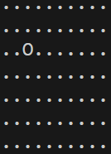
Instructions
- Initialize Variables
  - Define your "scene" size. This could be a grid of 10x10, for example.
  - Decide on a starting position for your ball, such as the center.
  - Decide on a representation for the ball (e.g., "O") and empty spaces (e.g., ".").
- Use lists to represent the scene's state. For each position in the grid, store either the ball's representation or an empty space.
- Capture Player Input
  - Use commands like 'W' for up, 'A' for left, 'S' for down, 'D' for right.
  - Add a quit command like 'Q'.
  - Make sure to validate the input, ensuring it's one of the allowed commands.
- Interpret the user's command to calculate the new position for the ball.
- Make sure the new position is within the grid's boundaries.
- Before updating the scene on the console, you'll need to clear the previous state. You can use the os module to help with this:
import os # at the top of your python program
os.system('cls' if os.name == 'nt' else 'clear')
- Print out the current state of your grid, showing the ball and empty spaces.
- Continually:
  - Capture the player's command.
  - Update the ball's position.
  - Clear the console.
  - Render the updated scene.
  - Exit the loop when the player decides to quit.
- Display a message to thank the player for playing when they decide to quit.

